Engineers for Exploration

Terrestrial Vehicle

2013-2014

Rover Assembly Instructions

Legend/Reference Page

|  |  |
| --- | --- |
| Picture | Description/Name |
| C:\Users\MACDV\Desktop\Final V4\Base Plate.JPG | Base Plate |
| C:\Users\MACDV\Desktop\Final V4\Aluminum Bar.JPG | Aluminum Bar |
| C:\Users\MACDV\Desktop\Final V4\Motor.JPG | Motors |
| C:\Users\MACDV\Desktop\Final V4\8-32 3.0'' Stainless Steel Screw.JPG | 8-32 3.0” Long Screw |
| C:\Users\MACDV\Desktop\Final V4\Final Shaft Collar.JPG | Shaft Collar |
| C:\Users\MACDV\Desktop\Final V4\Final 0.625'' Bore Sealed Bearing V4.JPG | Flanged Bearing |
| C:\Users\MACDV\Desktop\Final V4\Final Base-LR V4.JPG | Left/Right Side Plate |
| C:\Users\MACDV\Desktop\Final V4\Prototype ATR Wheel Assembly V3.JPG | Wheel |
| C:\Users\MACDV\Desktop\Final V4\Prototype ATR Wheel Hub V3.JPG | Wheel Hub |
| C:\Users\MACDV\Desktop\Final V4\Final Base-FB V4.JPG | Front/Back plate |
| C:\Users\MACDV\Desktop\Final V4\Final Inside Corner Bracket.JPG | Inside corner bracket |

Foreword:

This instruction manual will only cover the assembly of the main chassis, excluding the gimbal, gimbal platform, and electronics contained within the rover. Specifically, it will go over the construction of the drive train and body. Note that the order in which the steps are given is important as constructing the body out of order will lead to much difficulty and inefficiency. In reality, parts such as corner brackets and bearings will be marked to go into certain positions are, while interchangeable, best-fitted in their designated positions.

1. Begin by creating the wheel assembly. Using the packaged nuts and bolts, securely attach the wheel hubs to the wheel. Do this for all six wheels.

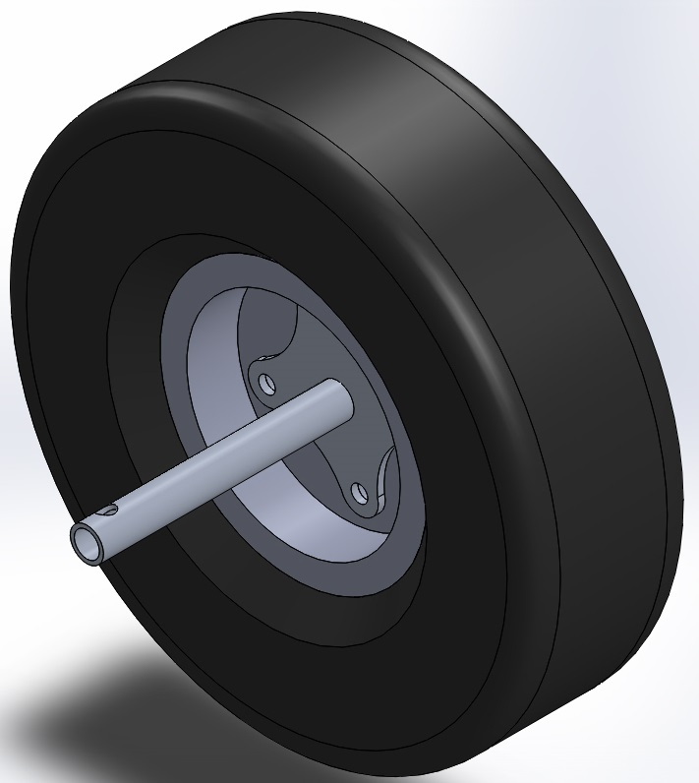

1. Using the 8-32 long screws, washers, and 8-32 nuts, attach the aluminum bars to the base plate. Take care to observe the proper orientation of the aluminum bars in order to properly affix the motors in the next step.

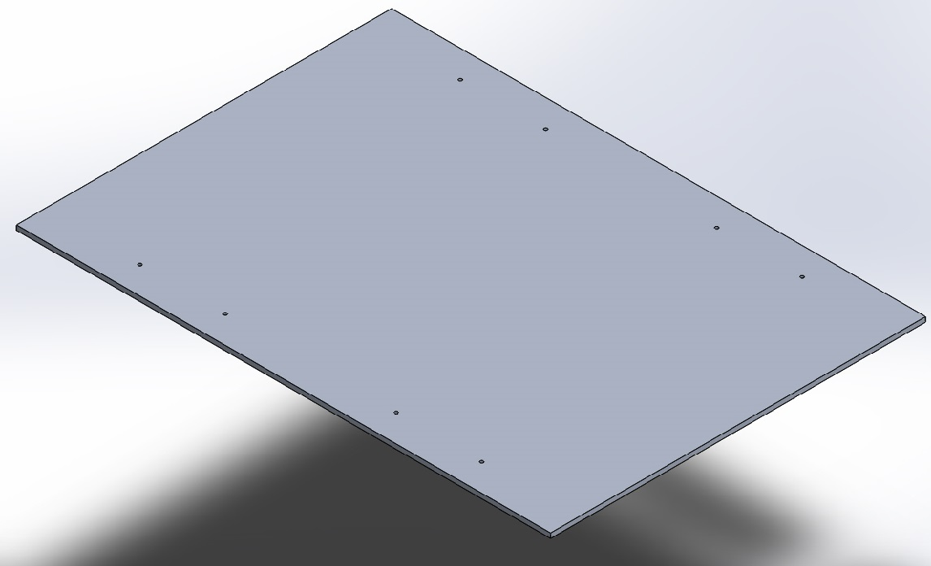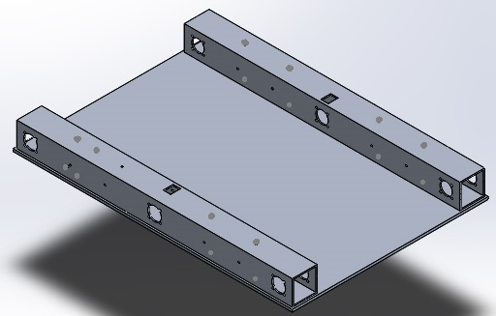

1. Using the provided motor screws, set each motor into the aluminum bar and screw them in through the radial pattern of clearance holes. If difficulty is found getting all the screws to fit in, it is advisable to loosely screw them all in first, and then tighten as the holes were not milled perfectly according to the CAD.

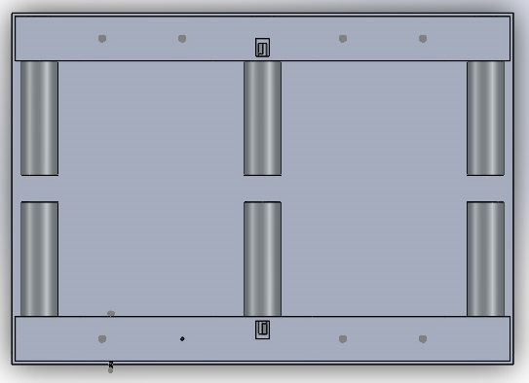

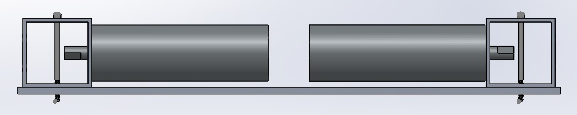

1. Slip the shaft collar around the motor axle and leave it there for now. The outermost shaft collars can be left until later, but the middle shaft collars are crucial for the installation of the wheels.

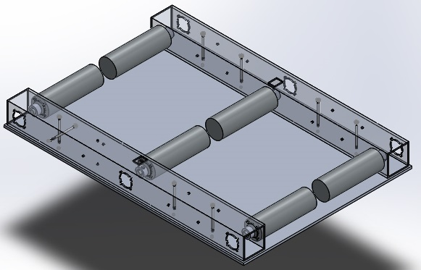

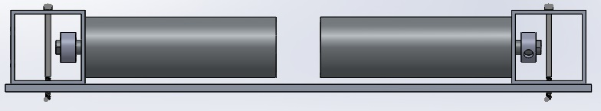

1. Install the flanged bearings into the aluminum bar, taking care to observe the labels on each bearing. (Example: R3 means it belongs on the right-sided aluminum bar in the third spot from the marked front.)

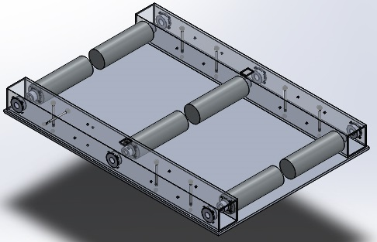

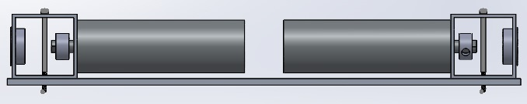

1. Attach the left and right side plates using the 8-32 long screws, nuts, and washers. Note: Use two washers for each screw between the left and right side plates and the aluminum bar so that, when the screws are tightened, the plates do not warp. (Washers not included)

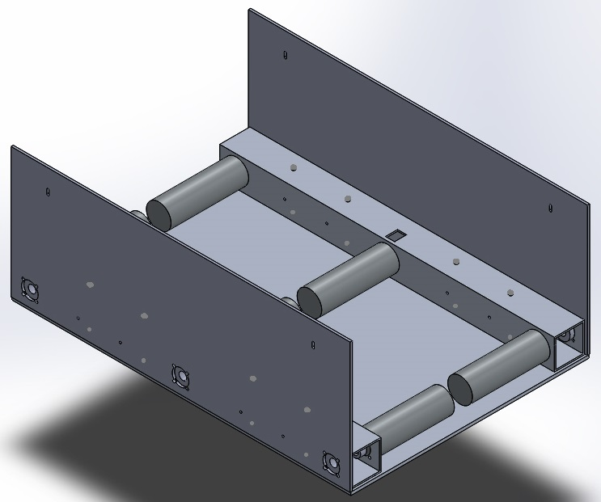

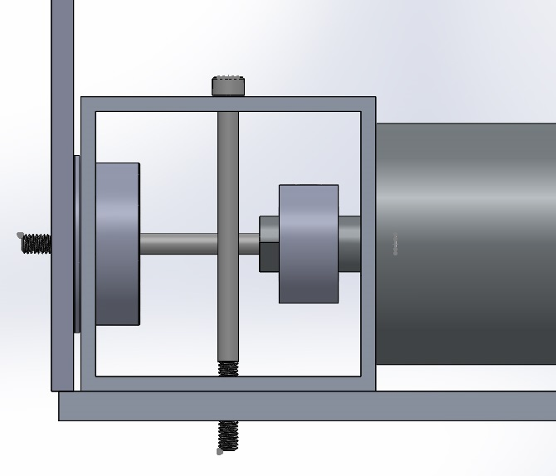

1. It is advisable to install the middle wheels first, as these are the most difficult. Slip the wheel hub axle through the bearing and onto the motor. Take care also to slip the shaft collar onto the wheel hub axle while aligning the set screw with the hole on the axle and the flat portion of the motor axle.

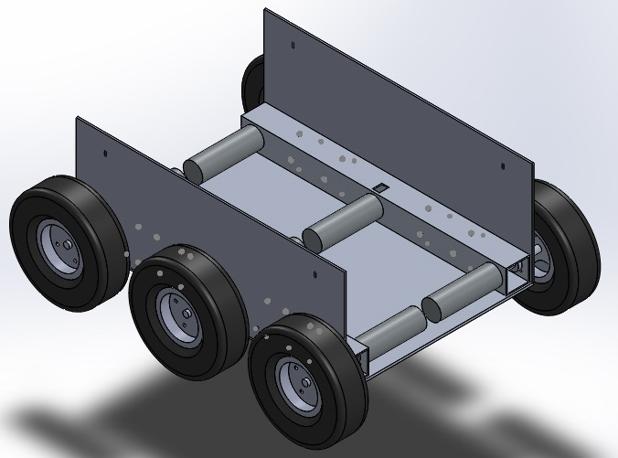

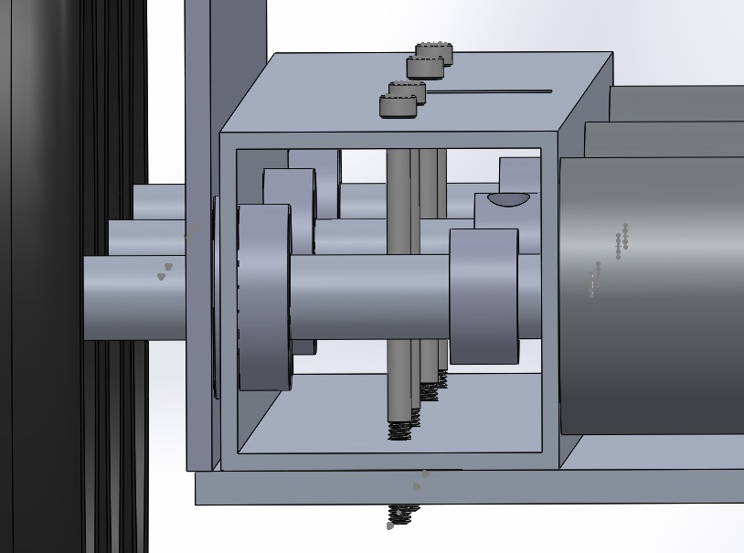

1. Match each inside corner bracket to their designated spot screw them in.

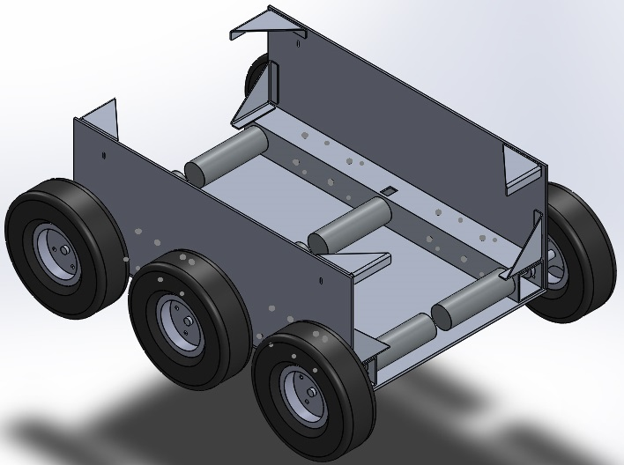

1. With the brackets in place, install the front and back plates using the corner brackets as a guide.

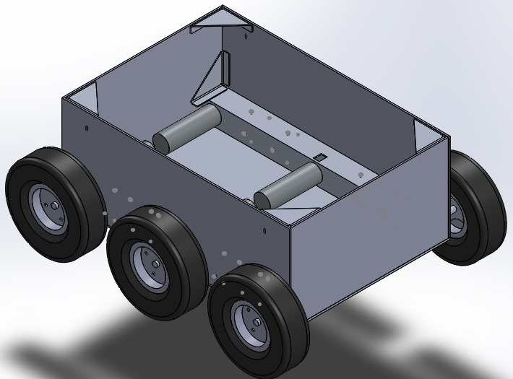

1. Additional step: Use your own discretion in forming and installing the wheel covers. The large flange can be drilled into and used as a built-in bracket with which to adjoin the cover to the main body.

